EXPT NO: 5 | IMPLEMENTATION OF A RECURRENT NEURAL NETWORK (RNN) FOR TEXT GENERATION
DATE: 24/08/2026

PRE-LAB QUESTIONS (PROVIDE BRIEF ANSWERS TO THE FOLLOWING QUESTIONS)

- Explain the purpose of a Recurrent Neural Network (RNN) in processing sequential data.

A Recurrent Neural Network (RNN) is designed to process data where the order of information is important, such as text, speech, and time-series data. It maintains a hidden state (memory) that carries information from previous elements of the sequence to the current element. This allows the RNN to learn patterns and dependencies across the sequence.

- Why is an RNN considered an appropriate model for text generation tasks?

RNNs are suitable for text generation because they can remember previously processed words or characters and use that information to predict the next one. For example, after reading “I am going to”, the RNN can use the previous words to predict a suitable next word such as “school”. This sequential prediction allows the model to generate text one word or character at a time.

- Describe the concept of sequence modeling in natural language processing.

Sequence modeling is the process of analyzing and learning patterns from data where the order of elements matters. In Natural Language Processing (NLP), words appear in a particular order and their meaning can depend on surrounding words. RNNs learn these relationships to perform tasks such as text generation, language translation, sentiment analysis, and speech recognition.

- Explain the importance of tokenization during text preprocessing for RNN-based text generation.

Tokenization is the process of breaking text into smaller units called tokens, such as words, subwords, or characters. For example:
"Hello World" → ["Hello", "World"]
Tokenization makes text easier for an RNN to process and allows each token to be assigned a numerical representation. It also helps the model learn relationships between individual words or tokens during training.

- Explain the significance of converting text into numerical representations before training an RNN.

RNNs cannot directly process raw text because neural networks operate on numerical data. Therefore, words or tokens are converted into numbers, usually using techniques such as integer encoding, one-hot encoding, or word embeddings. These numerical representations allow the RNN to perform mathematical operations and learn patterns, relationships, and dependencies in the text.

AIM
To implement a Recurrent Neural Network (RNN) for text generation and evaluate its ability to generate meaningful text by predicting the next word in a sequence.

SOFTWARE REQUIREMENTS
- Python
- TensorFlow or keras or PyTorch
- Google Colab
- GitHub
- Numpy
- Matplotlib

OBJECTIVES
Students will be able to:
- Understand the architecture and working of Recurrent Neural Networks (RNNs).
- Perform text preprocessing techniques for sequence modeling.
- Generate input sequences suitable for training an RNN model.
- Build and train an RNN model for text generation.
- Generate text by predicting the next word in a sequence.
- Evaluate the performance of the trained RNN using generated text.
- Analyze the effectiveness of RNNs in learning sequential patterns from textual data.

PROCEDURE
PART A: DATASET PREPARATION
Perform the following tasks:
- Load the Tiny Shakespeare dataset from Hugging Face.
- Explore the dataset and examine the text samples.
- Convert the text into lowercase (if required).
- Tokenize the text into individual words.
- Build a vocabulary and assign a unique integer index to each word.
- Generate input sequences for next-word prediction.
- Apply sequence padding to obtain inputs of equal length.
- Split the prepared sequences into training and validation datasets.

(CODE: CONATAINS STUDENT ROLL NOS
SCREENSHOT OF CODE
SCREENSHOT OF OUTPUT)

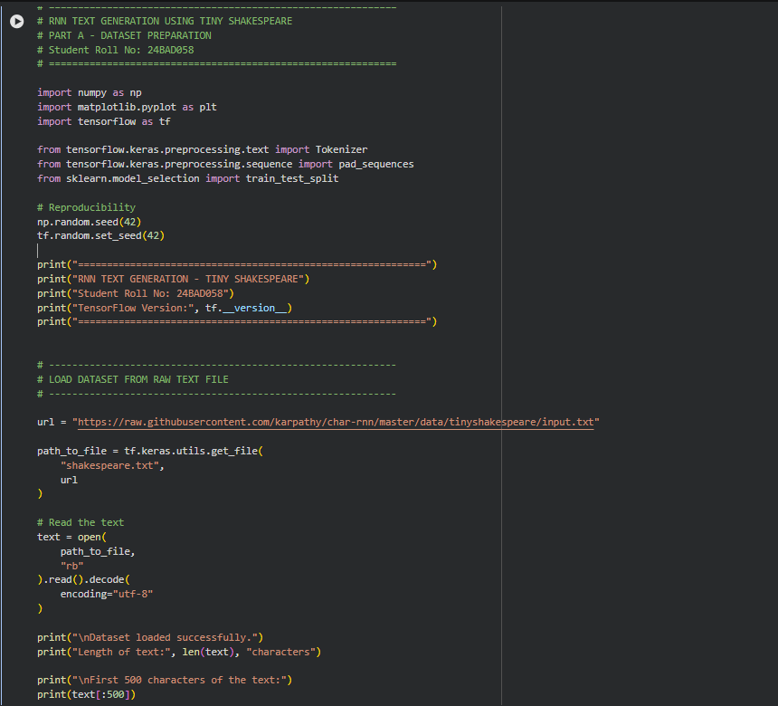

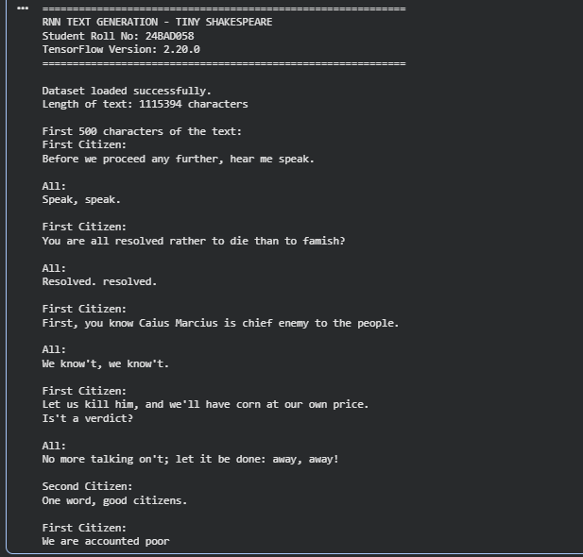

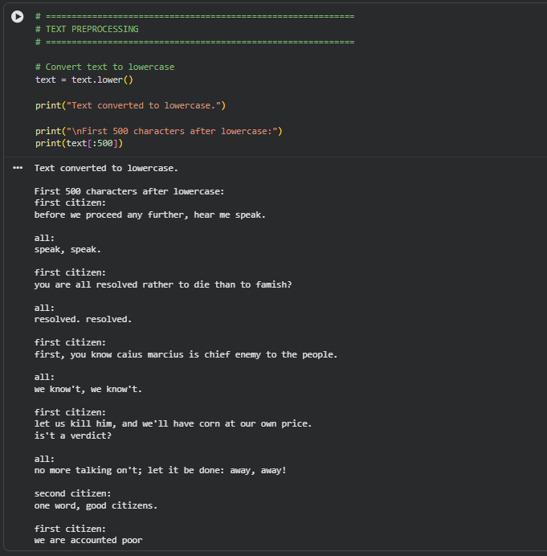

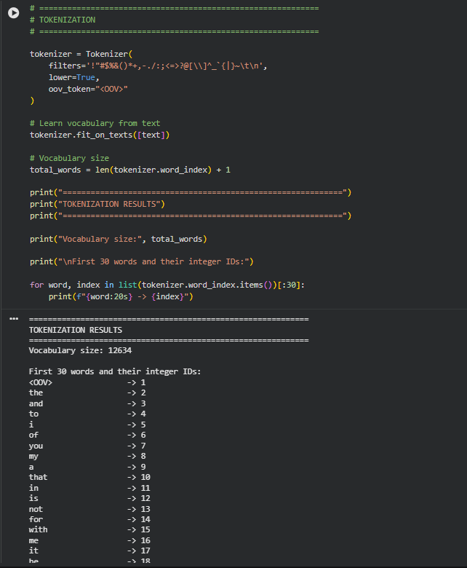

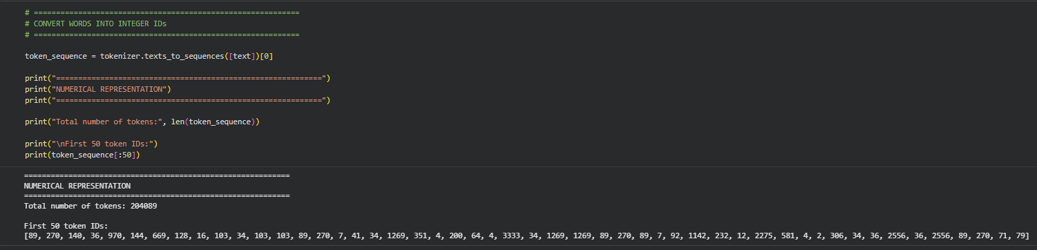

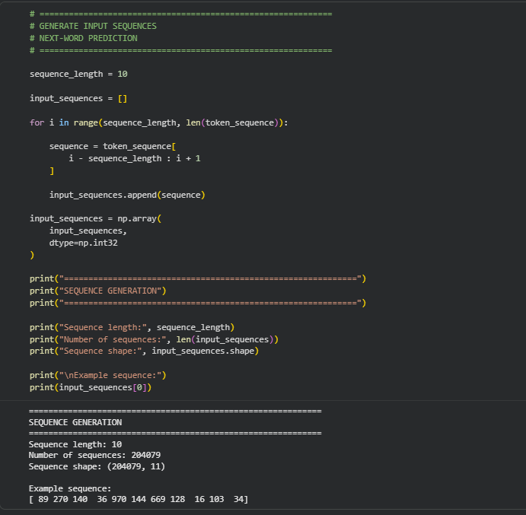

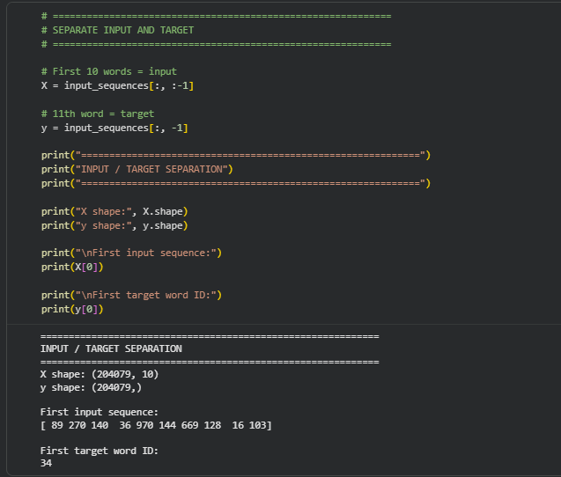

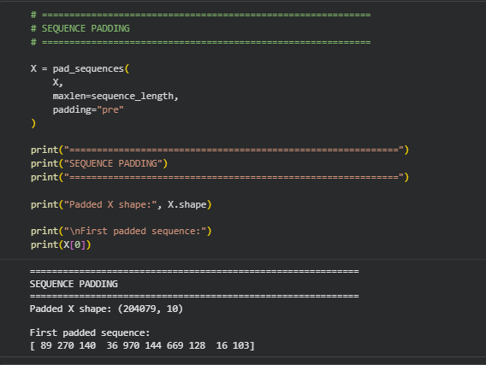

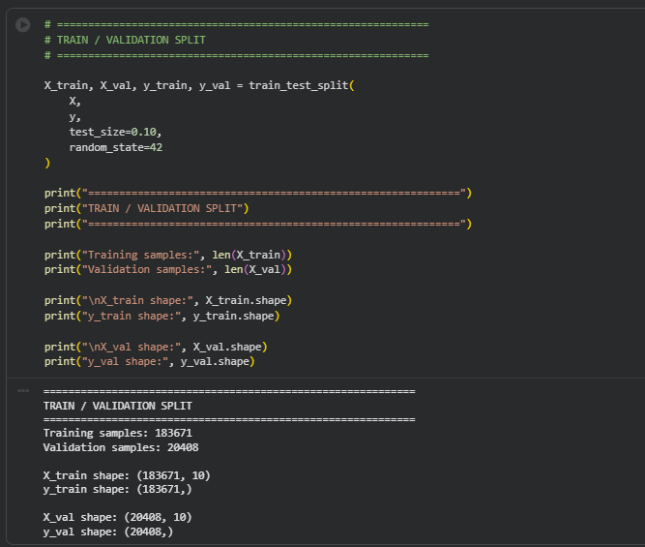

PART B: IMPLEMENTING THE RNN MODEL
Perform the following tasks:
- Create an Embedding layer to convert words into dense vector representations.
- Add a Simple RNN layer to learn sequential dependencies in the text.
- Add a Dense output layer with Softmax activation for next-word prediction.
- Compile the model using an appropriate optimizer and loss function.
- Display the model architecture and summary.

(CODE: CONATAINS STUDENT ROLL NOS
SCREENSHOT OF CODE
SCREENSHOT OF OUTPUT)

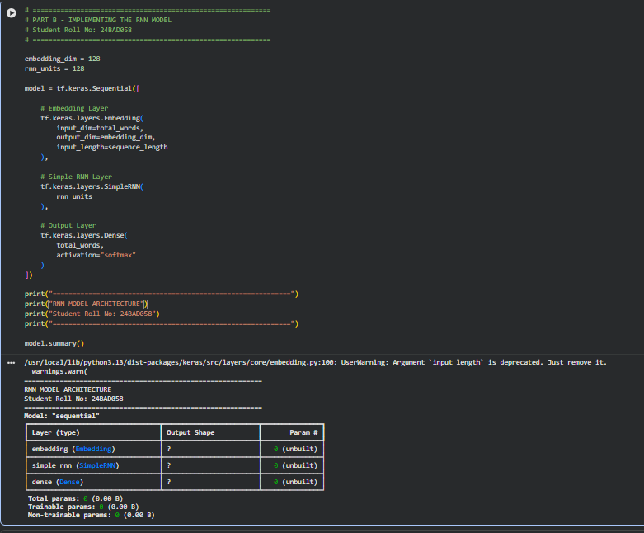

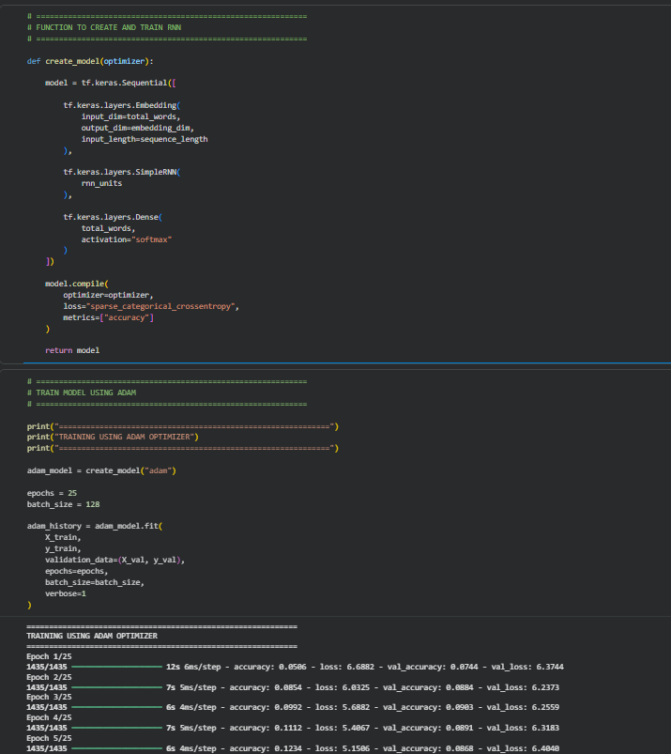

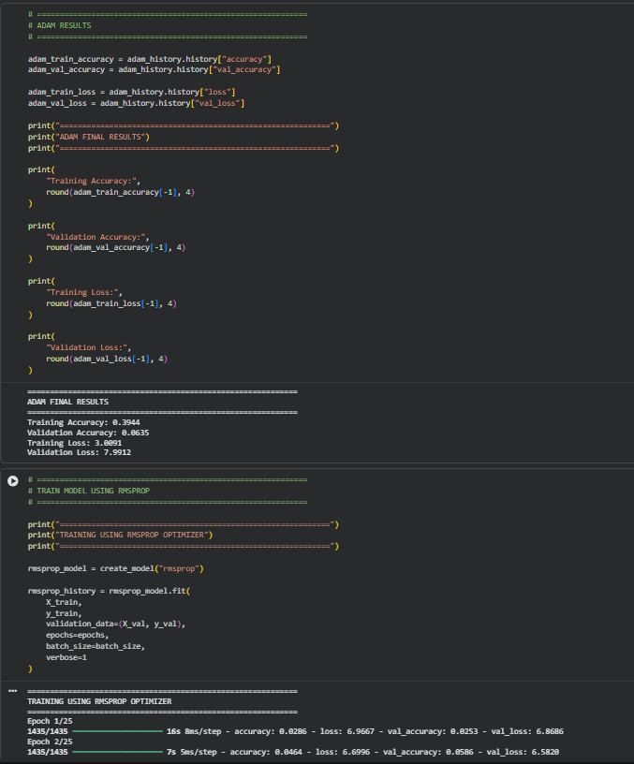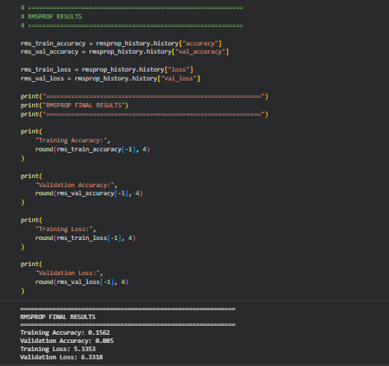

PART C: COMPARISON OF OPTIMIZATION ALGORITHMS
Perform the following tasks:
- Train the RNN model using the prepared training dataset.
- Validate the model using the validation dataset.
- Record:
  - Training accuracy
  - Validation accuracy
  - Training loss
  - Validation loss
- Visualize:
  - Accuracy vs. Epoch
  - Loss vs. Epoch

(CODE: CONATAINS STUDENT ROLL NOS
SCREENSHOT OF CODE
SCREENSHOT OF OUTPUT)

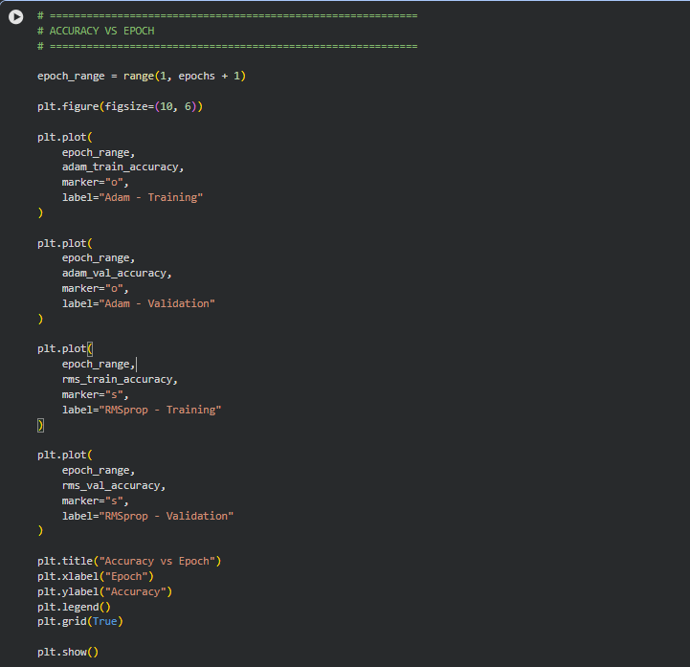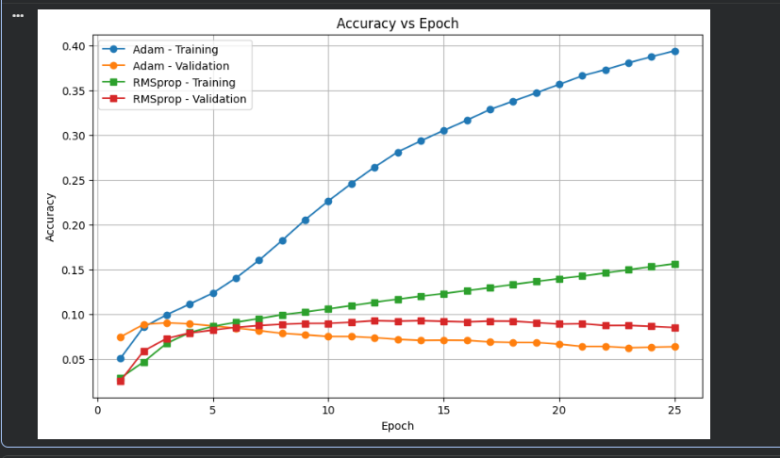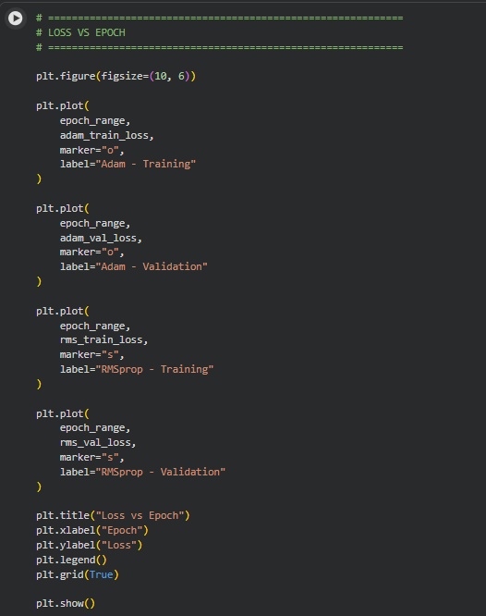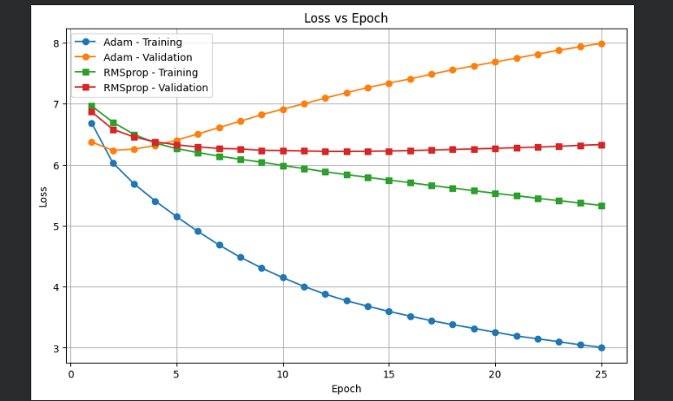

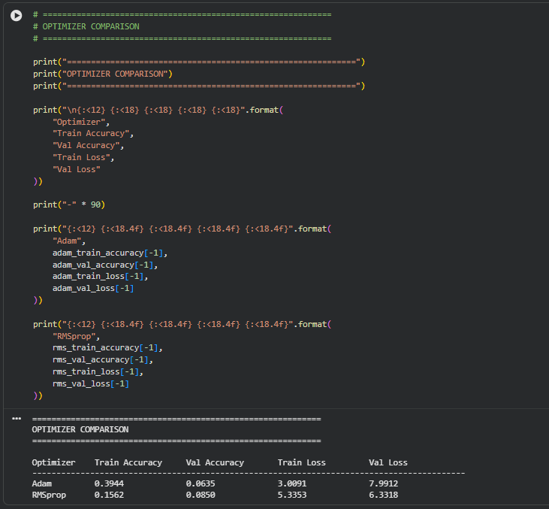
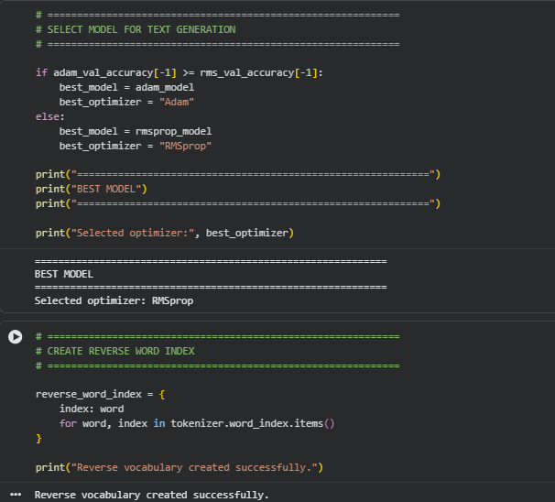

PART D: DEEP LEARNING EXPERIMENT MANAGEMENT
Perform the following tasks:
- Provide a seed word or sentence as input to the trained model.
- Generate text by repeatedly predicting the next word in the sequence.
- Produce multiple text samples using different seed inputs.
- Compare the generated text for coherence and contextual relevance.
- Document the observations and upload the notebook to GitHub.

(CODE: CONATAINS STUDENT ROLL NOS
SCREENSHOT OF CODE
SCREENSHOT OF OUTPUT)

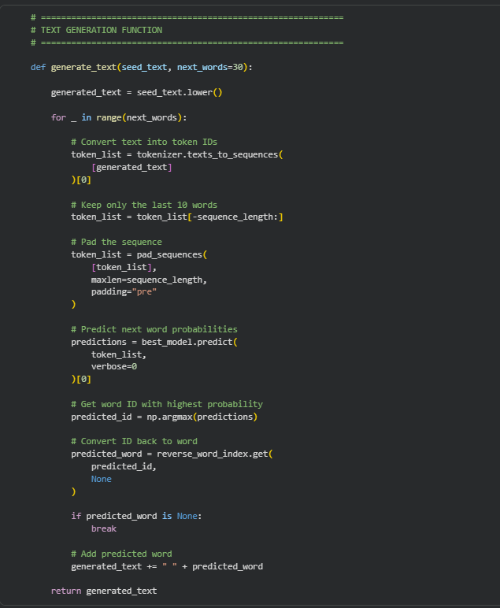

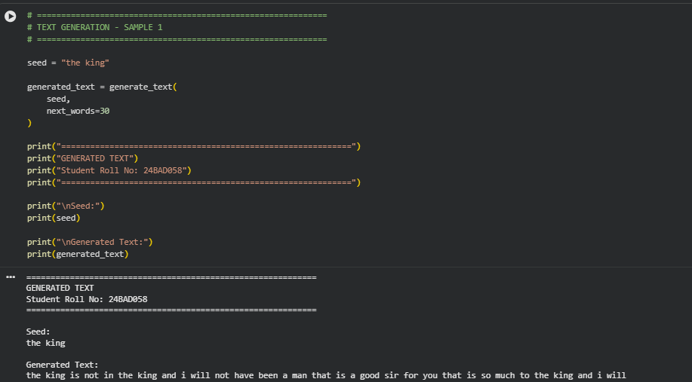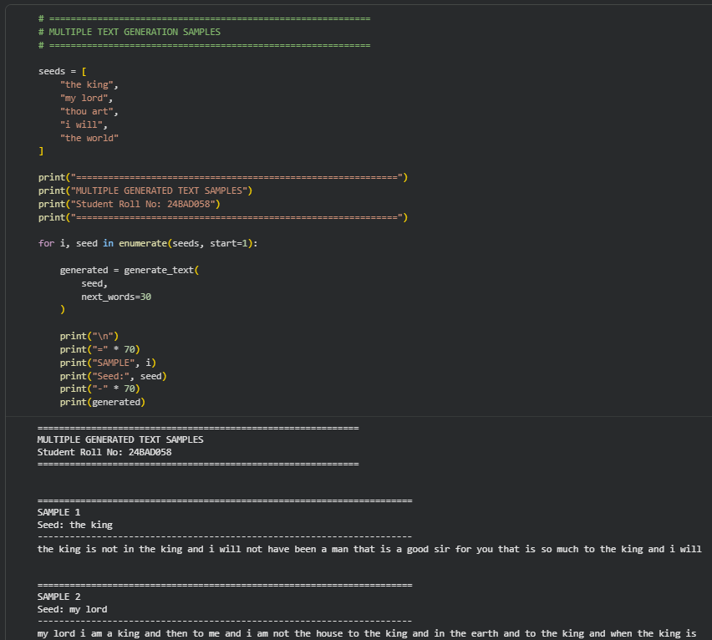

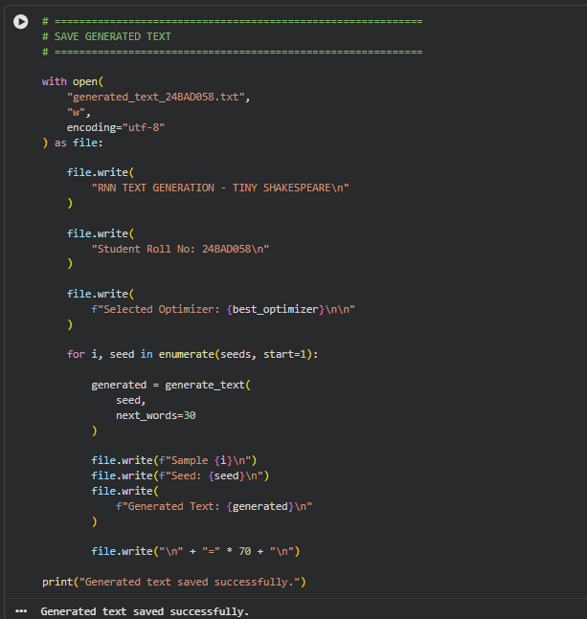
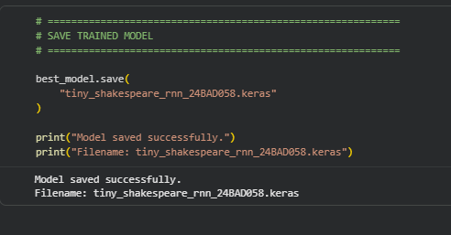

EXPECTED OUTCOME
Students will understand how an RNN learns sequential information and generates meaningful text based on previously learned patterns. Students will learn to preprocess textual data and train a Recurrent Neural Network (RNN) for text generation. They will evaluate the model's performance using training metrics and generate text through next-word prediction.

POST-LAB QUESTIONS (PROVIDE BRIEF ANSWERS TO THE FOLLOWING QUESTIONS)

- Describe the role of the hidden state in an RNN during sequence processing.

The hidden state acts as the memory of an RNN. It stores information from previous time steps and passes it to the next time step. This helps the RNN understand the relationship between words in a sequence and use previous context when predicting the next word.

- Discuss the effect of training an RNN model for an insufficient number of epochs.

If an RNN is trained for too few epochs, the model may underfit the data. It may not learn the important patterns and relationships in the text, resulting in low training and validation accuracy and poor-quality generated text.

- Explain the purpose of padding when preparing text sequences for RNN training.

Padding makes sequences of different lengths equal in size by adding special values, usually zeros, to shorter sequences. This allows all sequences to be processed together in batches by the RNN. Padding ensures that the input data has a consistent shape.

- Discuss one limitation of a Simple RNN when processing long text sequences.

A major limitation of a Simple RNN is the vanishing gradient problem. During training, gradients can become very small as they are propagated through many time steps. As a result, the RNN has difficulty remembering information from much earlier parts of a long sequence.

- Discuss the effect of sequence length on the performance of the text generation model.

Sequence length determines how many previous words the model uses to predict the next word. A longer sequence can provide more context and potentially improve text coherence, but it also increases computational requirements and can make training more difficult. A shorter sequence is faster to train but may not provide enough context, leading to less meaningful generated text.

ASSESSMENT
Description | Max Marks | Marks Awarded
Pre Lab Exercise | 5
In Lab Exercise | 10
Post Lab Exercise | 5
Viva | 10
Total | 30
Faculty Signature

